THE REPORT OF TE KOTAHITANGA
We welcome the opportunity to once again report to the General Synod / te Hīnota Whānui.
Current Membership
The Right Reverend Te Kitohi Pikaahu (Deputy Chair) (Tikanga Maori)
The Right Reverend Donald Tamihere (Tikanga Maori)
Mrs Jacqueline Pearse (Tikanga Maori)
The Right Reverend Richard Ellena (Tikanga Pakeha)
The Right Reverend Victoria Matthews (Tikanga Pakeha)
The Reverend Adrienne Bruce (Tikanga Pakeha)
The Most Reverend Dr Winston Halapua (Tikanga Pasefika)
The Venerable Christopher Solomona (Tikanga Pasefika)
The Reverend Sereima Lomaloma (Chair) (Tikanga Pasefika)
Ms Paula Jakeman (Executive Officer)
Tribute
The Venerable Te Hopehuia Hakaraia passed away on 9 July 2016. He was a member of Te Kotahitanga from May 2010 to February 2016 when he resigned to take up an appointment as Trustee to The St John’s College Trust Board. Te Hope was ordained deacon in 2011, priested the following year and became archdeacon of Education and Training for Te Hui Amorangi o te Upoko o Te Ika, as well as archdeacon and priest-in-charge of Rangiatea. Te Hope was the grandson of the Rt Rev’d Frederick Augustus Bennett, the first Bishop of Aotearoa, and nephew of the Rt Rev’d Manuhuia Augustus Bennett, third Bishop of Aotearoa. He was appointed a member of Te Kaunihera, the delegated governing body of The College of St John the Evangelist, when it was established in 2014, and was instrumental in developing the Te Kotahitanga strategic plan. His service and contribution to Te Kotahitanga was invaluable. Te Hope was laid to rest at his beloved Rangiatea on Tuesday 12 July 2016.
Canon II Title E Clause 3.11.
Under Canon II Title E Clause 3.11 Te Kotahitanga is responsible for exercising oversight of theological education, ministry training and formation, and other education and training relevant to advancing the mission and ministry of the Church.
The ministry of Te Kotahitanga has been assisted with the completion of the Te Kotahitanga Strategic Plan in 2016. This has established and provided a guide and focus on how Te Kotahitanga undertakes its ministry.
Over the last two years Te Kotahitanga has been assessing its modus operandi for the purpose of sharpening its accountability to the Canon and in particular, its major partner, the St John College Trust Board (SJCTB) and to the various stakeholders it serves: the three-Tikanga Church through the ministry bodies and the beneficiaries of the fund.
Talanoa
Te Kotahitanga usually hold three face-to-face meetings and one virtual meeting annually. With the availability of the video facility some members who are unable to be physically present, are able to link up digitally.
During the year Te Kotahitanga also meet with the Kinder Library Oversight Committee, the Chairperson of Te Kaunihera and the Manukura of St John the Evangelist, as well as the General Secretary of the Church, on behalf of the Common Life bodies that apply for programme funding under Section 3c of the St John’s College Trust Act.

The annual joint meeting with the St John’s College Trust Board is now superseded by regular meetings with the Chairperson and Secretary.
These talanoa sessions provide the opportunity for better understanding of the issues and developments within the respective bodies.
Funding for Programmes & Scholarships
The St John College Trust Board continue to make available $NZ12-15 million annually for “theological education, ministry training and other education relevant to advancing the mission and ministry of the Church.”
(i) The advice from Te Kotahitanga to SJCTB has resulted in some significant distributions to the Church. In 2016 and 2017, $12.6m and $13.2m respectively was made available to be distributed to beneficiaries. These figures do not include the costs associated with the lands and buildings on the St John the Evangelist site.
(ii) Since 2016 SJCTB has launched a new window of opportunity. Funding for “new initiatives” was introduced that targeted new or innovative ‘one off’ projects that could be funded up to three years, or for a shorter period. Applications are made annually, subject to availability of funding.
Scholarship Committee
The Scholarship Committee is the review body for scholarship applications from each Tikanga. Their recommendations are forwarded to Te Kotahitanga for consideration who then advise SJCTB. $843,818 was awarded to 98 recipients in 2016, $1,209,915 was awarded to 185 recipients in 2017, and $1,443,133 to 158 recipients in 2018.
Te Kotahitanga acknowledges and expresses its appreciation to the Chair, the Rev’d Dr Peter Carrell, and to all the members of the Scholarship Committee for their commitment in carrying out their responsibility.

Te Kaunihera
A separate report from Te Kaunihera, the Council that serves as the Matabose governing body of St John the Evangelist, is attached to this report.
Kinder Library Oversight Committee (KLOC)
A separate report from the Kinder Library Oversight Committee is attached to this report. Te Kotahitanga has continued its involvement with membership on that Committee since its inception in 2004.
Online Applications
Since 2017 St John’s College Trust Board has made it known that it intends to establish an online process for all programme and scholarship applications. This is still in its early stages of transition. To test this new process SJCTB called for proposals for “New Initiatives” in November 2017. All applications were submitted online and are currently being reviewed by Te Kotahitanga at the time of writing this report.
Core Priorities for our 3-Tikanga Church
Te Kotahitanga has developed three key strategic priorities for “theological education, ministry training and other education and training relevant to advancing the mission and ministry of the Church”, which all future applications will need to align to. They are:
- Theological programmes and resources that seek to uphold and promote the five marks of mission, with particular attention to evangelism, discipleship, social justice and climate change.
- To proclaim the Good News of the Kingdom
- To teach, baptise and nurture new believers
- To respond to human need by loving service
- To transform unjust structures of society, to challenge violence of every kind and pursue peace and reconciliation
- To strive to safeguard the integrity of creation, and sustain and renew the life of the earth
- To develop excellence in Christian leadership & governance.

- To develop excellence in Christian worship in the Anglican tradition.
Office of Te Kotahitanga
Te Kotahitanga acknowledges with deep gratitude the dedication of the Executive Officer, Ms Paula Jakeman. The Executive Officer was ably assisted by Ms Eliza Hei who was employed as an office assistant on a fixed term contract basis at the beginning of 2017. The contract will end in February 2018.
Conclusion
I conclude my very first report as Chair of Te Kotahitanga by acknowledging the members of Te Kotahitanga: Bishop Te Kitohi Pikaahu, Mrs Jackie Pearse, Bishop Don Tamihere, Bishop Richard Ellena, the Rev’d Adrienne Bruce, Bishop Victoria Matthews, Archbishop Winston Halapua and the Venerable Chris Solomona, remembering also, past members, Bishop Jim White and the Rev’d Dr Rangi Nicholson.
The Commission are ever grateful to the Executive Officer, Paula Jakeman. Her service to the ministry of Te Kotahitanga is evident and a blessing across our 3 Tikanga church.

The Revd Sereima Lomaloma, (Chair)

THE COLLEGE OF ST JOHN THE EVANGELIST
Te Whare Wānanga o Hoani Tapu te Kaikauwhau i te Rongopai

Tena koutou katoa, Malo e lelei, Greetings
As a result of decisions made at General Synod/Te Hīnota Whānui two years ago, governance responsibility for the College was delegated by Te Kotahitanga to Te Kaunihera in mid-2016. Since then, Te Kaunihera has spent time in developing and implementing a strategic plan for the College, making key appointments to support this work and undertaking a comprehensive appraisal of the Manukura to clarify any future developments needed.
Membership
Te Kaunihera consists of three Tikanga representatives and four appointed members. Currently these are the Most Rev’d Dr Winston Halapua (Tikanga Pasefika), the Rt Rev’d Dr Victoria Matthews (Tikanga Pakeha), the Rt Rev’d Don Tamihere (Tikanga Māori), the Rev’d Dr James Harding, Mr Jeremy Johnson, Miss Dawn Jones and the Rev’d Dr Rangi Nicholson. Mr Daniel Vincent was appointed as an alternate and replaced Jeremy Johnson when he took leave in 2017 to be part of the Working Group on Motion 29.
Tikanga representatives play a special role in bringing the ministry needs of each Tikanga before Te Kaunihera, including their future directions.
Strategic Directions
In late 2016 Te Kaunihera undertook a consultation with faculty and student representatives regarding the future direction of the College. From this came the following Statement of Commitment:
The College is the place where our Three Tikanga Church stands as one in the body of Christ.
A desire was also expressed “to celebrate the journey as a Three-Tikanga Church in a bicultural setting by establishing a ‘marae-church’ at the College that is an icon of this identity”.
Since then, Te Kaunihera has spent time developing a strategic plan based on these statements with a vision “to prepare and nurture a new generation of diverse and dynamic leaders for the Three Tikanga Church”. This would be done through:
- Ensuring excellence in theological training, formation and ministry development in residential-based education that will serve the ministry of the Church in Aotearoa, New Zealand and Polynesia
- Respecting the unique differences, needs and gifts of each Tikanga
- Being a worshipping Christian community that takes seriously reconciliation in Christ and is always seeking to live its life in loving service to God’s people and God’s world
- Providing an integral resource to the wider Church through the on-going development of distance education and various on-site options to utilize fully the residential resource
- Offering a prophetic voice to the Church by applying an Anglican lens on learning and engagement with contemporary issues in ministry and mission, both nationally and internationally.
Values were agreed and priority areas established. The College and Te Kaunihera are now working jointly on implementation of this plan. As part of this, the College has developed a Graduate Profile which is attached. A copy of the Strategic Plan may be found at www.stjohnscollege.ac.nz.
Curriculum Programmes
A strategic objective has been to develop and deliver a curriculum and pedagogy that will meet the future mission and needs of the Three Tikanga Church in a bi-cultural setting. Hence, the NZ Diploma in Christian Studies has been revised to meet strategic needs both at the College and in the regions.
The year now begins with a Three Tikanga programme, consisting of powhiri, hikoi and a four-week wānanga. The latter integrates online and study skills to scaffold students’ learning.
A new College Diploma will be introduced in 2019 and this will give standing to courses that have not previously contributed to qualifications. Regional programmes are to be supplemented by a flexi-learning option consisting of a regional intensive followed by live weekly online classes.
During 2017, six students were part of a new initiative, the Young Anglicans programme. Feedback indicated this was a very successful programme. The programme was not offered this year, but is expected to be available in 2019.
A six-months Tikanga Māori Leadership programme in 2016 was similarly considered to be very successful. It is hoped this course will be available again in the near future.
Students
The College has a full complement of 50 students for 2018 made up as follows:
 |  | ordinands/ordained | lay | vocational
Tikanga Pasefika | 12 | 7 | 3 | 2
Tikanga Pakeha | 26 | 22 | 3 | 1
Tikanga Māori | 9 | 6 | 2 | 1
Melanesia | 2 | 1 | 1
International | 1 | 1
Of these, 20 are in their first year, 12 in their second, 15 in their third and 3 are in their fourth year.
Regionally, the College delivers the Diploma in Christian Studies to over 90 students in Christchurch, Waikato/Taranaki, Waiapu, Wellington and Auckland.
Staff
In 2016, the resignation of the College Administrator provided an opportunity for a professional review of the College’s administrative structure. This led to the position of College Manager being established with wider responsibilities than previously. Mr Richard Swain, a chartered accountant with extensive senior administrative experience at The University of Auckland, was appointed.
Academic appointments made in this period include the Rev’d Dr Mark Harris (lecturer with oversight of ministry placements) and Mr Richard Cook (Director of Academic Programmes). The Rev’d Mark Barnard has recently been appointed to a one-year part-time position as a lecturer.
Student Accommodation
The College is pleased to see the St John’s College Trust Board exploring options for new student accommodation and it is working closely with the Board in the planning process. This means the College campus will look very different in the future, although every effort will be made to ensure it remains a reflective and contemplative environment.
Governance
Over the past two years, Te Kaunihera has worked closely with Justine O’Connell (Teesdale & Associates) and Julia Stones (HR2GO) in assessing its administrative structures (including the appointment of the College Manager) and establishing detailed appraisal systems. In addition, it has undertaken governance training led by Shelley Major (Major Consulting Group Ltd). Currently it is reviewing its meeting structures and systems so it can meet its governance responsibilities well.
Te Kaunihera retains close contact with both Te Kotahitanga and the St John’s College Trust Board. It appreciates the support given by both and is appreciative of the very good relationships that exist.
Appreciation
Te Kaunihera appreciates the work done by the Manukura, members of his Faculty and Staff. There is a strong desire for the College to serve the Church well and to provide the very best opportunities for students to learn and grow while there.

Dawn Jones (Chair, Te Kaunihera)
Tony Gerritsen (Manukura)

GRADUATE PROFILE
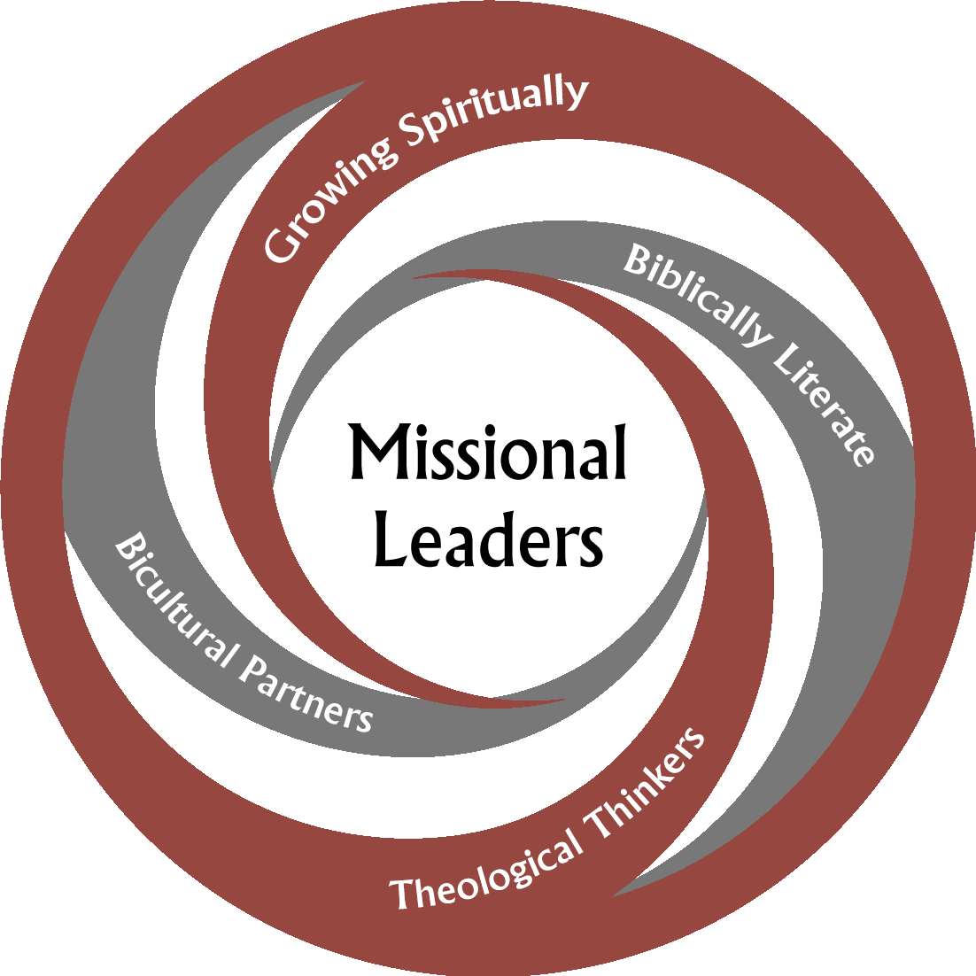
As Anglicans in Aotearoa New Zealand and Polynesia, committed to bicultural Treaty-based relationships in a Three Tikanga context, our graduates will be missional leaders who are:
- Growing spiritually as disciples of Jesus Christ and developing as reflective practitioners: Kia tupu ake hei tangata tapu hei tangata whaiwhakāro.
- Biblically literate through dwelling in, expounding, and integrating the Bible with confidence and insight in everyday contexts: Kia mōhio ki te paipera.
- Theological thinkers through critically reflecting upon scripture, tradition, reason and experience and engaging context with imagination and humility: Kia kakama ki te kaupapa Atuatanga.
- Bicultural partners who are growing in their understanding of reo and tikanga and the mana of different cultural expressions of the faith: Kia poua hei tangata tikanga rua.

THE KINDER LIBRARY OVERSIGHT COMMITTEE

Purpose and function
The Kinder Library Oversight Committee is appointed by Te Kotahitanga from nominations by Tikanga ministry bodies. Membership includes representation of all tikanga. Governance is devolved from Te Kotahitanga, and the line of accountability is through Te Kotahitanga. The role of the Committee is to provide governance, oversight and support for the John Kinder Theological library.
Vision Statement for the John Kinder Theological Library
As a resource for the whole Church, the John Kinder Theological Library supports in a collaborative manner St John’s College and regional resource centres, and will ensure access to the information resources of This Church and beyond.
Supporting the libraries of Te Manawa o Te Wheke, Te Taitokerau, St John the Baptist Theological College Suva, the Diocese of Dunedin, the Diocese of Waiapu, Vaughan Park Retreat Centre, Bishop Sutton Library - Bishopdale Theological College Nelson, the Wellington Institute of Theology, Franciscans Hamilton, Te Rau College, Gisborne and Theology House Christchurch.
Committee membership
Rev’d Adrienne Bruce (Chair, and representing Te Kotahitanga)
The Rev’d Dr W R Nicholson (Tikanga Maori)
M. Hangartner (contributing library experience)
Rev’d C A Chambers (representing regional resource centres)
Mrs J K Bright (Librarian, John Kinder Theological Library)
The John Kinder Theological Library continues to focus on the development of a coordinated library service for the Church. New strategic goals were developed for the 2014-2018 period.
The following have been achieved in the 2016-2017 period
- New software packages to give an integrated search tool for books, full text articles and e-books that is also mobile friendly
- New website
- Continued shared library cataloguing by the staff of the John Kinder Theological Library for nine other libraries. A total of 28,500 titles have now been catalogued for regional libraries
- Summary statistics:
      - 2016 books added – JKTL 2849; regional libraries 1536
      - 2017 books added – JKTL 1393; regional libraries 1349
- Support by post and email for regional students with 126 packages of books and 65 scans of chapters or articles supplied in 2017, and a higher number in 2016, suggesting that the new software is enabling students to find their own resources
- Regional libraries operating to a high standard and supporting study in a number of Hui Amorangi and Dioceses
- Church Papers Online: the full text searchable collection of Anglican and Methodist church newspapers has been expanded to 26 titles including Anglican Taonga and Synod Proceedings /Yearbooks for the Diocese of Auckland
- Photograph collections online
- Initial development of concept of church register content online up to 1920

Concerns have been raised as to the future of some regional libraries and a need to continue to look creatively at information resourcing.

The current structure of the Kinder Library Oversight Committee provides good support for the Library and is enabling a diversified library and archives service to the whole Church.

Revd Adrienne Bruce (Chair)

